OUTCOME BUDGET
2013-14

MINISTRY OF CULTURE

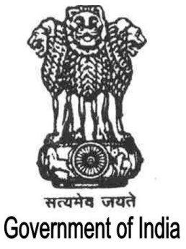

GOVERNMENT OF INDIA

Contents

Executive Summary | i-iii
Chapter I | 1-15
Chapter II | 16 - 141
Chapter III | 142-148
Chapter IV-A | 149-274
Chapter IV-B | 275-420
Chapter V | 421-433
Chapter VI | 434-455

